**Cryptography**

### -Lab report



Submitted By: Deshant Devkota

Submitted To: Suresh Thapal (Lecturer, Cryptography)

Vedas College, Lalitpur, Nepal

**Tribhuvan University**

**Department of Bsc Csit**

Submitted Date: Saturday, June 5, 2021

Submitted Lab Reports:

1. To implement Caesar Cipher
2. To implement Playfair Cipher
3. To implement Monoalphabetic Cipher
4. To implement Vignere Cipher
5. To implement Hill Cipher
6. To implement Rail Fence Cipher
7. To implement Row Transpose Cipher

## LAB 1

Caesar Cipher

**1. Objectives:**

In this lab we were to implement Caesar Cipher and use it to encrypt and decrypt a message.

**2. Introduction:**

Caesar Cipher is a substitution Cipher technique in which each letter of plain text is replaced by a letter with some fixed number of positions down with the alphabet. It is named after Julius Caesar since he introduced the use of this cipher.

Encryption with Caesar code is based on an alphabet shift (move of letters further in the alphabet), it is a monoalphabetic substitution cipher, ie. a same letter is replaced with only one other (always the same for a given cipher message). The most commonly used shift/offset is by 3 letters

**4.Code:**

//Implementing Caesar Cipher in C++

#include<iostream>

#include<string>

#include<algorithm>

using namespace std;

void remove_LC_spaces(string& text)

{

string formatted_text;

for(auto text_single_char:text)

{

if (text_single_char!=' ')

{

{formatted_text += tolower(text_single_char);}

}

}

text = formatted_text;

}

string encrypt_using_caesar(string text)

{

remove_LC_spaces(text);

for(auto& single_text_char:text)

{

single_text_char = (((single_text_char+3-97)%26)+97);

}

return text;

}

string decrypt_using_caesar(string text)

{

remove_LC_spaces(text);

for(auto& single_text_char:text)

{

single_text_char = (((single_text_char-3-97+26)%26)+97);

}

return text;

}

int main()

{

string plain_text, cipher_text, decipher_text;

cout<<"Enter plain text: ";

getline(cin,plain_text);

cipher_text = encrypt_using_caesar(plain_text);

cout<<"\nCipher text is: "<<cipher_text<<endl;

decipher_text = decrypt_using_caesar(cipher_text);

cout<<"\nDecipher text is: "<<decipher_text<<endl;

}

**5.Output:**

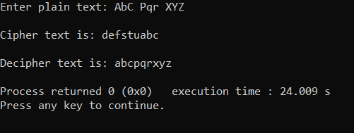

Fig:Output for Encryption and Decryption using Caesar Cipher

## LAB 2

PlayFair Cipher

**1. Objectives:**

In this lab we were to implement Playfair Cipher and use it to encrypt and decrypt a message.

**2. Introduction:**

The Playfair cipher is a manual symmetric encryption technique and was the first literal diagram substitution cipher. The scheme was invented in 1854 by Charles Wheatstone. Lord Playfair is credited for promoting its use.

**4.Code:**

//Implementing Playfair Cipher in C++

#include<iostream>

#include<vector>

#include<map>

#include<string>

#include<utility>

#include <algorithm>

using namespace std;

string remove_LC_spaces_j(const string& text)

{

string return_text;

for(auto text_single_char:text)

{

if (text_single_char!=' ')

{

if (text_single_char=='j' || text_single_char=='J')

{return_text += 'i';}

else

{return_text += tolower(text_single_char);}

}

}

return return_text;

}

void display_playfair_matrix(char playfair_matrix[5][5])

{

for(int row=0;row<5;row++)

{

for(int column=0;column<5;column++)

{

cout<<playfair_matrix[row][column]<<" ";

}

cout<<endl;

}

}

void generate_playfair_matrix(char playfair_matrix[5][5], string key)

{

int row=0, column=0;

map<char, int> mp;

mp['j']=1;

for(auto key_single_char:key)

{

if(mp[key_single_char]==0)

{

playfair_matrix[row][column]=key_single_char;

mp[key_single_char]=1;

column = (column+1)%5;

if (column==0)

row = (row+1)%5;

}

}

for(char alphabet='a';alphabet<='z';alphabet++)

{

if(mp[alphabet]==0)

{

playfair_matrix[row][column]=alphabet;

mp[alphabet]=1;

column = (column+1)%5;

if (column==0)

row = (row+1)%5;

}

}

}

map<char, pair<int, int>> map_char_pos(const char playfair_matrix[5][5])

{

map<char, pair<int, int>> char_row_column_map;char element;

for(int row=0;row<5;row++)

{

for(int column=0;column<5;column++)

{

element = playfair_matrix[row][column];

char_row_column_map[element]=make_pair(row,column);

}

}

return char_row_column_map;

}

vector<pair<char,char>> divide_string_to_pairs(string plain_text)

{

vector<pair<char,char>> plain_text_pair_vector;

for(int i=0;i<plain_text.size();i++)

{

if(i!=plain_text.size()-1)

{

if(plain_text[i]!=plain_text[i+1])

{

plain_text_pair_vector.push_back(make_pair(plain_text[i],plain_text[i+1]));

//plain_text_pair_vector[i].first=plain_text[i];

//plain_text_pair_vector[i+1].first=plain_text[i];

i++;

}

else if(plain_text[i]==plain_text[i+1])

{

plain_text_pair_vector.push_back(make_pair(plain_text[i],'x'));

}

}

else

{

plain_text_pair_vector.push_back(make_pair(plain_text[i],'x'));

}

}

return plain_text_pair_vector;

}

string encrypt_using_play_fair(string plain_text, string key)

{

char playfair_matrix[5][5];

plain_text=remove_LC_spaces_j(plain_text);

key=remove_LC_spaces_j(key);

generate_playfair_matrix(playfair_matrix, key);

cout<<"\nThe 5*5 Play Fair Matrix or Key Table is:\n";

display_playfair_matrix(playfair_matrix);

map<char, pair<int,int>> char_row_column_map = map_char_pos(playfair_matrix);

cout<<"\nThe row and column for each char in the 5*5 table is: \n";

for(auto iter:char_row_column_map)

{

cout<<iter.first<<":<"<<iter.second.first<<","<<iter.second.second<<">"<<endl;

}

vector<pair<char,char>> plain_text_pair_vector = divide_string_to_pairs(plain_text);

cout<<"\nThe Plain Text divided into Pairs: \n";

for(auto single_pair_item:plain_text_pair_vector)

{

cout<<single_pair_item.first<<","<<single_pair_item.second<<endl;

}

//The main work

//Generating Cipher Text

//using the pairs which are inserted in vector

string ciphertext;

char first_letter, second_letter;

int flr,flc,slr,slc;

for(auto single_pair_item:plain_text_pair_vector)

{

first_letter=single_pair_item.first;

second_letter=single_pair_item.second;

flr=char_row_column_map[first_letter].first;

flc=char_row_column_map[first_letter].second;

slr=char_row_column_map[second_letter].first;

slc=char_row_column_map[second_letter].second;

if(flr==slr)

{

ciphertext+=playfair_matrix[flr][(flc+1)%5];

ciphertext+=playfair_matrix[slr][(slc+1)%5];

}

else if(flc==slc)

{

ciphertext+=playfair_matrix[(flr+1)%5][flc];

ciphertext+=playfair_matrix[(slr+1)%5][slc];

}

else

{

ciphertext+=playfair_matrix[flr][slc];

ciphertext+=playfair_matrix[slr][flc];

}

}

return ciphertext;

}

string decrypt_using_play_fair(string plain_text, string key)

{

cout<<"\nThis is Decryption Process:\n";

char playfair_matrix[5][5]{NULL};

plain_text=remove_LC_spaces_j(plain_text);

key=remove_LC_spaces_j(key);

generate_playfair_matrix(playfair_matrix, key);

cout<<"\nThe 5*5 Play Fair Matrix or Key Table is:\n";

display_playfair_matrix(playfair_matrix);

map<char, pair<int,int>> char_row_column_map = map_char_pos(playfair_matrix);

cout<<"\nThe row and column for each char in the 5*5 table is: \n";

for(auto iter:char_row_column_map)

{

cout<<iter.first<<":<"<<iter.second.first<<","<<iter.second.second<<">"<<endl;

}

vector<pair<char,char>> plain_text_pair_vector = divide_string_to_pairs(plain_text);

cout<<"\nThe Cipher Text divided into Pairs: \n";

for(auto single_pair_item:plain_text_pair_vector)

{

cout<<single_pair_item.first<<","<<single_pair_item.second<<endl;

}

//The main work Generating Cipher Text using the pairs which are inserted in vector

string ciphertext;char first_letter, second_letter; int flr,flc,slr,slc;

for(auto single_pair_item:plain_text_pair_vector)

{

first_letter=single_pair_item.first;

second_letter=single_pair_item.second;

flr=char_row_column_map[first_letter].first;

flc=char_row_column_map[first_letter].second;

slr=char_row_column_map[second_letter].first;

slc=char_row_column_map[second_letter].second;

if(flr==slr)

{

ciphertext+=playfair_matrix[flr][(flc-1+5)%5];

ciphertext+=playfair_matrix[slr][(slc-1+5)%5];

}

else if(flc==slc)

{

ciphertext+=playfair_matrix[(flr-1+5)%5][flc];

ciphertext+=playfair_matrix[(slr-1+5)%5][slc];

}

else

{

ciphertext+=playfair_matrix[flr][slc];

ciphertext+=playfair_matrix[slr][flc];

}

}

return ciphertext;

}

int main()

{

string plain_text, key, cipher_text, decipher_text;

cout<<"Enter plain text: ";

getline(cin,plain_text);

cout<<"\nEnter Key: ";

getline(cin,key);

cipher_text = encrypt_using_play_fair(plain_text,key);

cout<<"\nCipher text is: "<<cipher_text<<endl;

decipher_text = decrypt_using_play_fair(cipher_text,key);

cout<<"\nDecipher text is: "<<decipher_text<<endl;

}

**5.Output:**

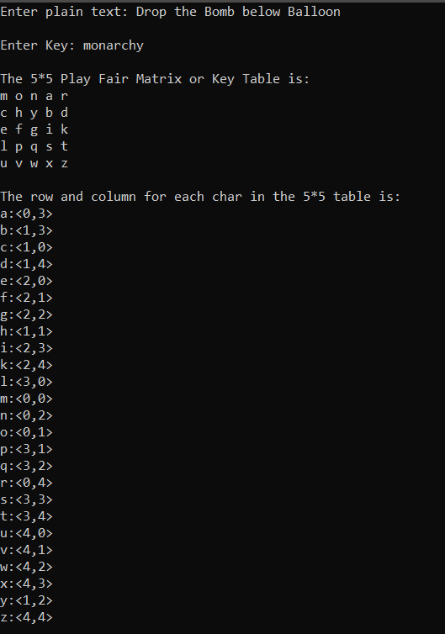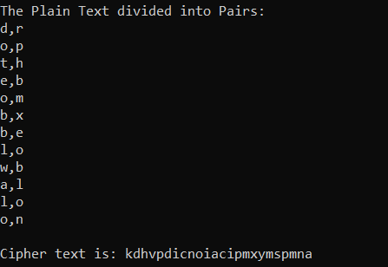

Fig: Output for Encryption using PlayFair Cipher

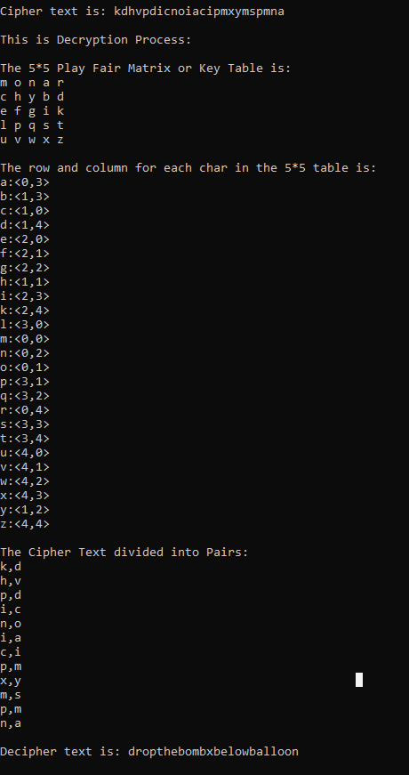

Fig: Output for Decryption using Playfair Cipher

## LAB 3

Mono-alphabetic Cipher

**1. Objectives:**

In this lab we were to implement Mono-Alphabetic Cipher and use it to encrypt and decrypt a message.

**2.Introduction:**

A monoalphabetic substitution cipher, also known as a simple substitution cipher, relies on a fixed replacement structure. That is, the substitution is fixed for each letter of the alphabet. Thus, if "a" is encrypted to "R", then every time we see the letter "a" in the plaintext, we replace it with the letter "R" in the ciphertext.

**3.Code:**

//Code to implement mono-alphabetic cipher using C++

#include<iostream>

#include<map>

#include<string>

#include<algorithm>

using namespace std;

void remove_UC_spaces(string& text)

{

string formatted_text;

for(auto text_single_char:text)

{

if (text_single_char!=' ')

{

formatted_text += tolower(text_single_char);

}

}

text = formatted_text;

}

int main()

{

string plain_text, cipher_text, decipher_text;

char letter;

map<char,char> key_map;

cout<<"Enter key map to map alphabets: \n";

for(char i='a'; i<='z'; i++)

{

cout<<i<<" => ";

cin>>letter;

key_map[i]=toupper(letter);

}

fflush(stdin);

cout<<"\nEnter plain text: ";

getline(cin,plain_text);

remove_UC_spaces(plain_text);

for(auto letter:plain_text)

{

cipher_text += key_map[letter];

}

cout<<"\nCipher text is: "<<cipher_text<<endl;

//Reverse mapping

for(auto letter:cipher_text)

{

for(auto iter:key_map)

{

if(iter.second==letter)

decipher_text+=iter.first;

}

}

cout<<"\nDecipher text is: "<<decipher_text<<endl;

}

**4.Output:**

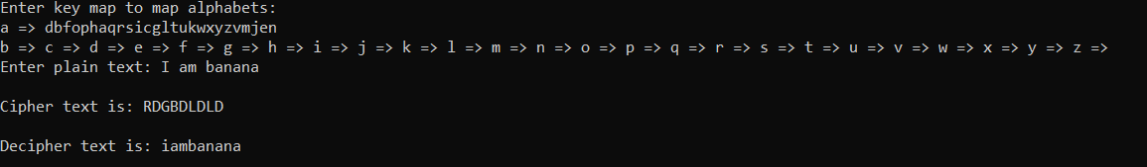

Fig:Output for Encryption and Decryption using Mono-alphabetic Cipher

## LAB 4

Vigenère Cipher

**1.Objective**

In this lab we were to implement Vigenère Cipher and use it to encrypt a message.

**2.Introduction**

Vigenere Cipher is a method of encrypting alphabetic text. It uses a simple form of polyalphabetic substitution. A polyalphabetic cipher is any cipher based on substitution, using multiple substitution alphabet .

The encryption of the original text is done using the Vigenère square or Vigenère table. The table consists of the alphabets written out 26 times in different rows, each alphabet shifted cyclically to the left compared to the previous alphabet, corresponding to the 26 possible Caesar Ciphers. At different points in the encryption process, the cipher uses a different alphabet from one of the rows. The alphabet used at each point depends on a repeating keyword.

**3.Code:**

//Code to implement Vigenere Cipher in C++ to encrypt a message

#include<iostream>

#include<string>

#include<algorithm>

using namespace std;

void remove_LC_spaces(string& text)

{

string formatted_text;

for(auto text_single_char:text)

{

if (text_single_char!=' ')

{

{formatted_text += tolower(text_single_char);}

}

}

text = formatted_text;

}

void fit_key_to_text(string& key, int ts, int ks)

{

if(ts>ks)

{

for(int i=0;i<ts-ks;i++)

{

key.push_back(key[i%ks]);

}

}

}

string encrypt_using_vignere(string text, string key)

{

string cipher_text;

remove_LC_spaces(text);

remove_LC_spaces(key);

fit_key_to_text(key,text.size(),key.size());

cout<<"\nNew key: "<<key<<endl;

for(int i=0;i<text.size();i++)

{

cipher_text+=((((text[i]-'a')+(key[i]-'a'))%26)+97);

}

return cipher_text;

}

int main()

{

string plain_text, key, cipher_text;

cout<<"Enter plain text: ";

getline(cin,plain_text);

cout<<"\nEnter key: ";

getline(cin,key);

cipher_text = encrypt_using_vignere(plain_text,key);

cout<<"\nCipher text is: "<<cipher_text<<endl;

}

**4.Output:**

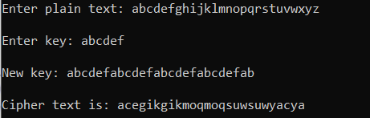

Fig: Encryption using Vigenere Cipher

## LAB 5

Hill Cipher

**1. Objective:**

In this lab we were to implement Hill Cipher and use it to encrypt a message.

**2.Introduction:**

Hill cipher is a polygraphic substitution cipher based on linear algebra.Each letter is represented by a number modulo 26. Often the simple scheme A = 0, B = 1, …, Z = 25 is used, but this is not an essential feature of the cipher. To encrypt a message, each block of n letters (considered as an n-component vector) is multiplied by an invertible n × n matrix, against modulus 26. To decrypt the message, each block is multiplied by the inverse of the matrix used for encryption.

The matrix used for encryption is the cipher key, and it should be chosen randomly from the set of invertible n × n matrices (modulo 26).

**3.Code:**

//Code to implement Hill Cipher in C++ to encrypt a message

#include<iostream>

#include<string>

#include<math.h>

using namespace std;

void remove_LC_spaces(string& text)

{

string formatted_text;

for(auto text_single_char:text)

if (text_single_char!=' ')

formatted_text += tolower(text_single_char);

text = formatted_text;

}

void create_key_matrix(char* key_matrix, string key, int block_size)

{

int ks=key.size();

//fitting key size to no of matrix elements

if(block_size*block_size>ks)

for(int i=0; i<block_size*block_size-ks;i++)

key+='x';

for(int row=0;row<block_size;row++)

for(int col=0;col<block_size;col++)

key_matrix[row*block_size+col]=key[row*block_size+col];

}

string encrypt_using_hill_cipher(string text, string key, int block_size)

{

string return_text;

char product=0;

int ts=text.size();

char key_matrix[block_size][block_size];

remove_LC_spaces(text);

ts=text.size();

remove_LC_spaces(key);

//key_matrix is a pointer which points to 1D array of integers (i.e first element of 2D array)

//key_matrix[0] is a pointer which points to first element of 1D array of integers

//same as *key_matrix

create_key_matrix(key_matrix[0], key, block_size);

//displaying key_matrix formed

cout<<"\nThe key matrix created is: "<<endl;

for(int i = 0; i < block_size; i++)

{

for(int j = 0; j < block_size; j++)

printf("%c ", key_matrix[i][j]);

printf("\n");

}

//padding text with extra letters to make multiple of block_size

while(ts%block_size!=0)

{

text.push_back('x');

ts=text.size();

}

int m,t,p=0;

//multiplying key_matrix with text

for(int i=0;((i+1)*block_size)<=ts;i++)

{

for(int row=0; row<block_size; row++)

{

for(int col=0; col<block_size; col++)

{

m=key_matrix[row][col]-97;

t=text[i*block_size+col]-97;

p+=m*t;

}

p=(p%26)+97;

product = p;

return_text+=product;

p=0;

}

}

return return_text;

}

int main()

{

string plain_text, key, cipher_text;

int block_size;

cout<<"Enter plain text: ";

getline(cin,plain_text);

cout<<"\nEnter Key: ";

getline(cin,key);

cout<<"\nEnter Block Size: ";

cin>>block_size;

cipher_text = encrypt_using_hill_cipher(plain_text,key,block_size);

cout<<"\nCipher text is: "<<cipher_text<<endl;

}

**4.Output:**

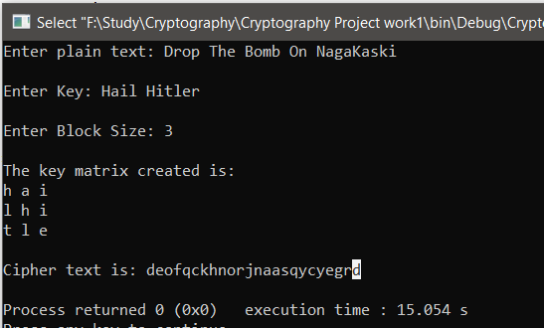

## LAB 6

Rail Fence Cipher

**1.Objective:**

In this lab we were to implement Rail fence Cipher and use it to encrypt and decrypt a message.

**2.Introduction:**

The Rail Fence cipher works by writing your message on alternate lines across the page, and then reading off each line in turn. For example, the plaintext "defend the east wall" is written as shown below, with all spaces removed.

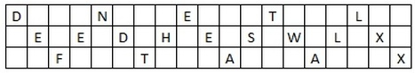

**3.Code:**

//

#include<iostream>

#include<string>

#include<algorithm>

using namespace std;

void remove_LC_spaces(string& text)

{

string formatted_text;

for(auto text_single_char:text)

if (text_single_char!=' ')

formatted_text += tolower(text_single_char);

text = formatted_text;

}

string encrypt_using_rail_fence(string plain_text,int key)

{

remove_LC_spaces(plain_text);

int msgLen = plain_text.size();

char matrix[key][msgLen];

for(int row=0; row<key; row++)

for(int col=0; col<msgLen; col++)

matrix[row][col]='\n';

int row=0; bool dir=0;

for(int col=0; col<msgLen; col++)

{

matrix[row][col]=plain_text[col];

if(row==0||row==key-1)

dir=!dir;

dir?row++:row--;

}

string cipher_text;

for(int row=0; row<key; row++)

for(int col=0; col<msgLen; col++)

if(matrix[row][col]!='\n') cipher_text+=matrix[row][col];

return cipher_text;

}

string decrypt_using_rail_fence(string text,int key)

{

remove_LC_spaces(text);

int msgLen = text.size();

char matrix[key][msgLen];

for(int row=0; row<key; row++)

for(int col=0; col<msgLen; col++)

matrix[row][col]='\n';

int row=0; bool dir=0;

for(int col=0; col<msgLen; col++)

{

matrix[row][col]='*';

if(row==0||row==key-1)

dir=!dir;

dir?row++:row--;

}

int i=0;

for(int row=0; row<key; row++)

for(int col=0; col<msgLen; col++)

if(matrix[row][col]=='*') matrix[row][col]=text[i++];

string cipher_text;

for(int row=0; row<key; row++)

for(int col=0; col<msgLen; col++)

if(matrix[row][col]!='\n') cipher_text+=matrix[row][col];

return cipher_text;

}

int main()

{

string plain_text, cipher_text, decipher_text;

int key =3;

cout<<"Enter plain text: ";

getline(cin,plain_text);

cout<<"\nEnter Key: ";

cin>>key;

cipher_text = encrypt_using_rail_fence(plain_text,key);

cout<<"\nCipher text is: "<<cipher_text<<endl;

decipher_text = decrypt_using_rail_fence(plain_text,key);

cout<<"\nCipher text is: "<<decipher_text<<endl;

}

**4.Output:**

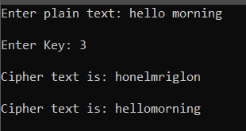

## LAB 7

Row Transpose Cipher

**1.Objective:**

In this lab we were to implement Row Transpose Cipher and use it to encrypt and decrypt a message.

**2.Introduction:**

In row transposition we write down the string in a matrix starting from the first row to the last going through each column. Then we alter the columns in order defined using the key. We then

read the letters from the first column to the last going through each row.

For eg: A string “hello world” is written in a 3*4 matrix as below

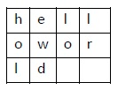

The columns are then exchanged in a order defined by key maybe “3214” and the letters are read from top to bottom fashion which will produce a ciphertext as “lo ewdhollr “.

**3.Code:**

def split_len(seq, length):

return [seq[i:i + length] for i in range(0, len(seq), length)]

def encode(key, plaintext):

order = {

int(val): num for num, val in enumerate(key)

}

ciphertext = ''

for index in sorted(order.keys()):

for part in split_len(plaintext, len(key)):

try:

ciphertext += part[order[index]]

except IndexError:

continue

return ciphertext

print(encode('3214', 'DROP THE BOMB'))

**4.Output:**



============================End===================================